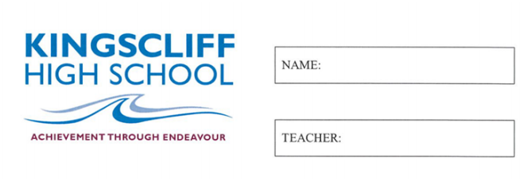

MATHEMATICS

Year 7

Practice Exam 3

2026

Time allowed: 50 mins
5 mins reading time
Instructions  1. Attempt all questions  2. Show working where needed  3. A calculator is NOT permitted |  | Sections and Marks  Part A (Multiple Choice) – 15 Marks  Part B (Calculations) – 30 Marks  Part C (Data and Probability) – 18 Marks  Total – 63 Marks

Part A
1. | Which word describes the difference between the highest and lowest values in a set of data?  a) Mean b) Mode  c) Range d) Median
2. | The median of 8, 3, 5, 9, 1 is:  a) 3 b) 5  c) 8 d) 9
3. | Which calculation follows the order of operations correctly?  a) 2 + 3 × 4 = 20 b) 2 + 3 × 4 = 14  c) (2 + 3) × 4 = 14 d) 2 × (3 + 4) = 10
4. | Which shows 0.5, 0.05, 5, 0.55 in descending order?  a) 5, 0.55, 0.5, 0.05 b) 0.05, 0.5, 0.55, 5  c) 5, 0.5, 0.55, 0.05 d) 0.55, 5, 0.5, 0.05
5. | In the number 9.207, the digit 7 is in which place?  a) Tenths b) Hundredths  c) Thousandths d) Ten thousandths
6. | What is the value of 3³?  a) 9 b) 27  c) 6 d) 33
7. | Which of the following contains a variable?  a) 12 + 5 b) 3 × 7  c) y + 4 d) 20 ÷ 2
8. | Which set of angles could be the three angles of a triangle?  a) 50°, 60°, 80° b) 90°, 45°, 45°  c) 100°, 60°, 30° d) 70°, 70°, 70°
9. | Which statement about an isosceles triangle is correct?  a) It has no equal sides  b) It has two equal sides and two equal angles  c) All of its angles are 90°  d) It has four sides
10. | A square has sides of 6 cm. What is its perimeter?  a) 12 cm b) 24 cm  c) 36 cm d) 6 cm
11. | The temperature is −3 °C and then rises by 5 degrees. The new temperature is:  a) −8 °C b) 8 °C  c) 2 °C d) −2 °C
12. | A standard die is rolled. How many outcomes in the sample space are even numbers?  a) 2 b) 3  c) 4 d) 6
13. | Which of these could NOT be a value of P(E)?  a) 0 b) 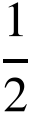  c) 1 d) 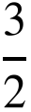
14. | An angle of exactly 90° is called:  a) Acute b) Right  c) Obtuse d) Straight
15. | Angles that form a ‘Z’ shape between parallel lines are called:  a) Corresponding b) Co-interior  c) Alternate d) Vertically opposite

Part B
1. | Calculate the missing angle and provide working out. | 2  marks
  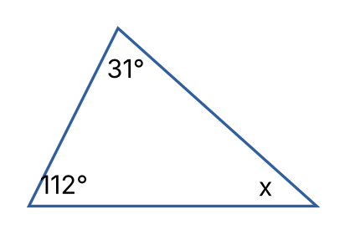 | _____________________  _____________________  _____________________  _____________________
2. | Calculate the size of the exterior angle marked a° and provide working out. | 2  marks
  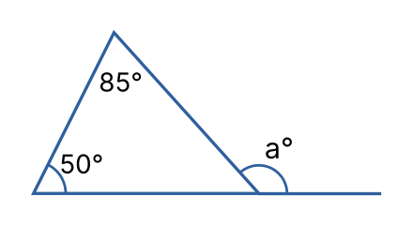 | _____________________  _____________________  _____________________  _____________________
3. | State True or False for each of the following:  a) 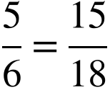 b) 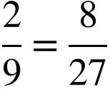 | 2  marks
4. | Calculate the following:  a) 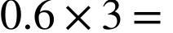 b) 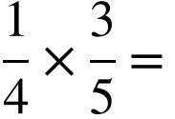 | 2  marks
5. | Calculate the following:  a) 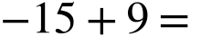  b) 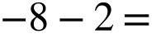  c) 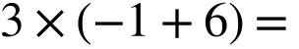 | 3  marks
6. | Convert into a mixed number:  a) 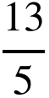  Convert into an improper fraction:  b) 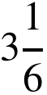 | 2  marks
7. | Write an algebraic expression for each statement. Use to represent the number:  i) 7 less than the number  ii) Twice the number, plus 1 | 2  marks
8. | If 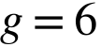, 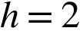 and 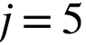  Solve the following by substitution:  i) 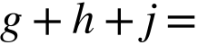  ii) 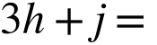 | 2  marks
9. | Simplify the following:  i) 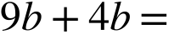  ii) 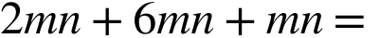  iii) 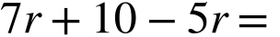  iv) 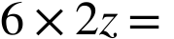 | 4  marks
10. | Calculate the following (use a mental or written strategy):  i) 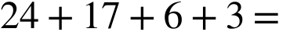  ii) 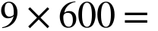  iii) 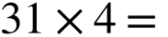 | 3  marks
11. | Solve the following equations:  i) 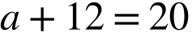  ii) 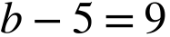  iii) 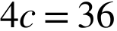  iv) 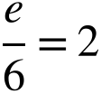  v) 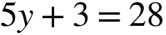  vi) 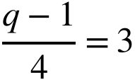 | 6  marks

Part C
12. | The list below shows how many times each student in 7B bought lunch from the canteen in one term:  4 5 3 6 5 4 7 5 2 4  5 6 3 5 14 4 6 5 3 4  i) Construct a dot plot from the above set of data  ii) How many students are in the data set?  iii) What is the mode?  iv) What is the range?  v) How many students bought lunch fewer than 4 times?  vi) Is there an outlier? If so, what is it? | 7  marks
13. | Observe the following set of data:  5, 9, 3, 7, 11, 4, 8, 6, 10  Calculate the following:  i) The mean  ii) The median  If 17 was added to the data set, what would be:  iii) The new median?  iv) The new mean? | 4  marks
14. | Observe the following graph and answer the questions below.  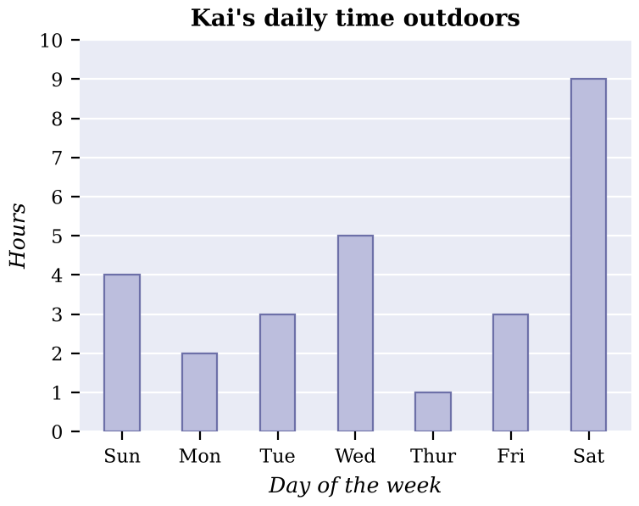  i) How many hours did Kai spend outdoors on Wednesday?  ii) On which day did Kai spend the least time outdoors?  iii) How many hours did Kai spend outdoors over the whole week shown?  iv) What fraction of Saturday did Kai spend outdoors? Give your answer in simplest form. | 4  marks
15. | 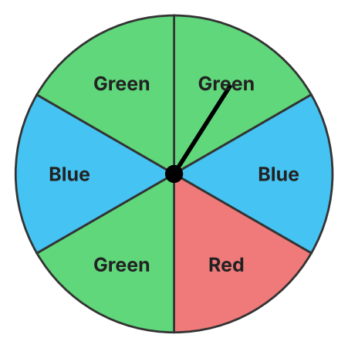  Observe the spinner above. Each section is the same size.  a) List the sample space:  b) What is the probability of spinning blue?  c) What is the complement of spinning green, and what is its probability? | 3  marks

